Course: CS420 - Artificial Intelligence

03 – Constraint Satisfaction Problems

Question 1. You are designing a menu for a special event. The menu includes four dishes, each of which is a variable: (A)ppetizer, (B)everage, main (C)ourse, and (D)essert.
The domains of the variables are as follows:
A: (v)eggies, (e)scargot
B: (w)ater, (s)oda, (m)ilk
C: (f)ish, (b)eef, (p)asta
D: (a)pple pie, (i)ce cream, (ch)eese
Because all of your guests get the same menu, it must obey the following dietary constraints:
(i) Vegetarian options: If you serve the veggies, you must avoid everything made of meat (red meat, poultry, seafood, etc.)
(ii) Dairy products lover: You must serve at least one of milk, ice cream, or cheese.
(iii) Digestible: The main course must be fish or the beverage must be water or soda.

Formulate the problem as a CSP, stating the variables and corresponding domains.
Variables | A | B | C | D
Domains | v,e | w,s,m | f,b,p | a,i,ch
Binary constraints:
A and C (constraint i) | B and C (constraint iii) | B and D (constraint ii)

Draw the constraint graph associated with your CSP, in which each node represents a variable and an edge connecting two nodes represents the relation between the two variables denoted by these nodes. | 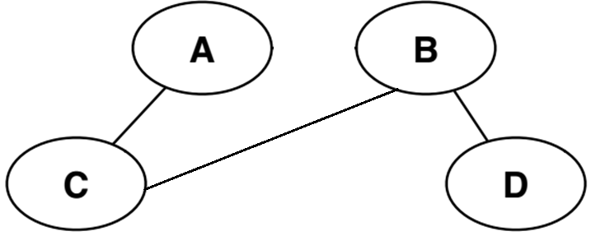
Again imagine we first assign A=v. Cross out eliminated values to show the domains of the variables after arc consistency has been enforced.
Variables | A | B | C | D
Domains | v | w,s, m | f,b,p | a,i,ch

Give a solution for this CSP or state that none exists.
One of many solutions: A = v, B = w, C = p, D = i
Question 2. You are a map-coloring robot assigned to color the given map. Adjacent regions must be colored a different color (R=Red, B=Blue, G=Green).  - Draw the constraint graph  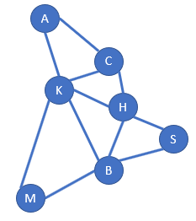 | 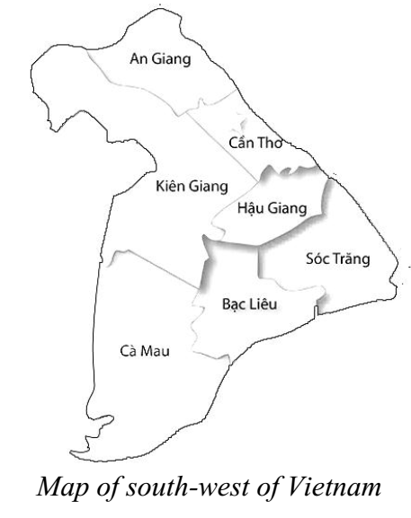
- Find a solution by using backtracking search with appropriate heuristics (MRV, DH, and LCV). Explain your answer in detail.
LCV is implicitly implemented by the order of coloring: R, G, and B.
- Initially, all vertices have the same MRV = 3. Kien Giang has the highest DH = 5 → Kien Giang: Red (Figure A)
- An Giang, Bac Lieu, Ca Mau, Can Tho and Hau Giang have the same lowest MRV = 2. Bac Lieu and Hau Giang have the same highest DH = 3. Choose randomly among those vertices → Bac Lieu: Green (Figure B)
- Ca Mau and Hau Giang have the same lowest MRV = 1. Hau Giang has a higher DH = 2 → Hau Giang: Blue (Figure C)
- Can Tho, Ca Mau, and Soc Trang have the same lowest MRV = 1. Can Tho has the highest DH = 1 → Can Tho: Green (Figure D)
- Remaining vertices are isolated ones → Soc Trang: Red, Ca Mau: Blue, An Giang: Blue
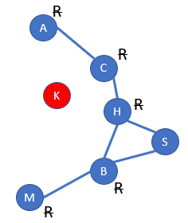 | 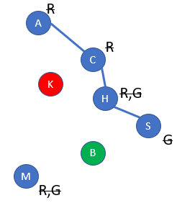 | 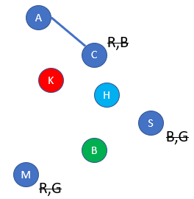 | 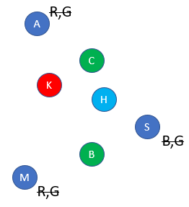
A | B | C | D
